Projects at Tecnológico de Monterrey Mexico
Project: 6-week projects for University in Mexico
Software: OnShape / SolidWorks
Year: 2023 - 2024

Project 1: Slider-crank mechanism
Objective
To be able to cut paper using a small 5V DC-Motor.
Design Process
As a team, we opted for a simple tablelike design. The biggest issue was the slider since we had to use the blade from a bow saw, so having teeth everywhere was a problem. We eventually solved it by adding a bar and a hole inside the saw that would ensure the blade stayed vertical.
Manufacturing
The whole thing was manufactured using existing pieces and wood. We used a laser cutter for the small parts, and the big parts were made manually.
Images
- CAD render
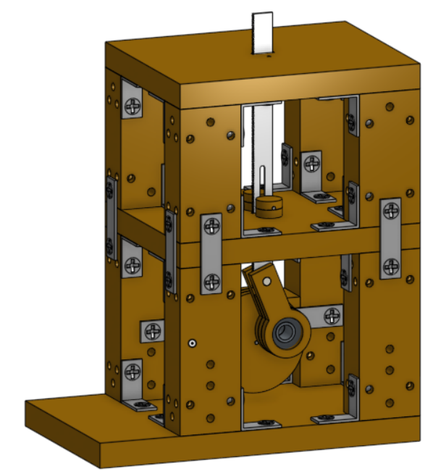

- Close-up view
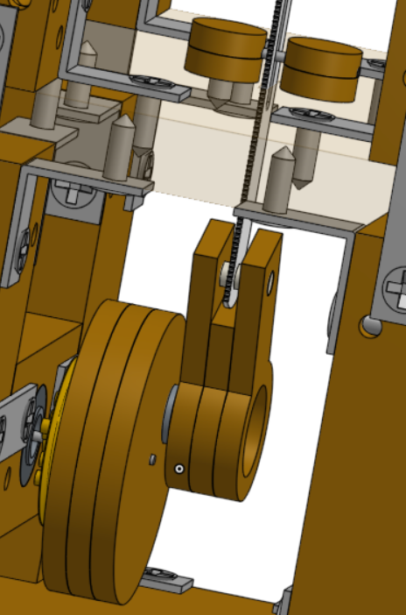
- Photo of the finished manufactured product
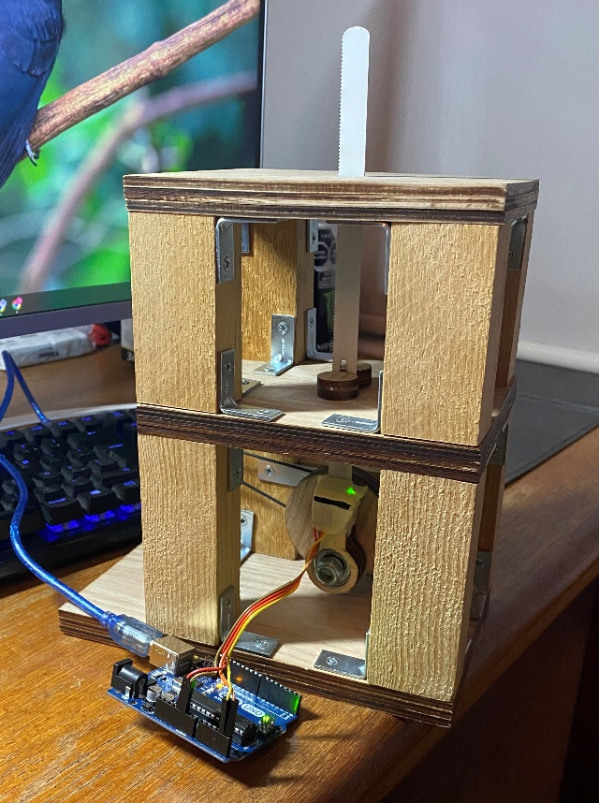
Project: OnShape
Project 2: Water pump
Objective
Develop a pump that creates a circulatory flow and add a flow sensor to test for leaks inside the system.
Design Process
Since my knowledge in water pumps was zero, the main body was taken from an online experienced creator, and then further modifications and the completion of the whole body was done by me.
Manufacturing
This item was printed in 3D and other parts like the shaft were bought and implemented to the system according to their measurements
Images
- CAD render
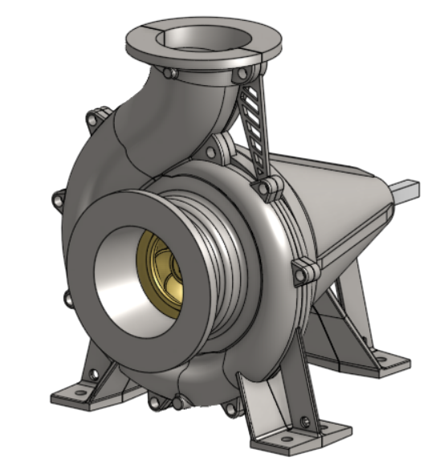

- Inside view
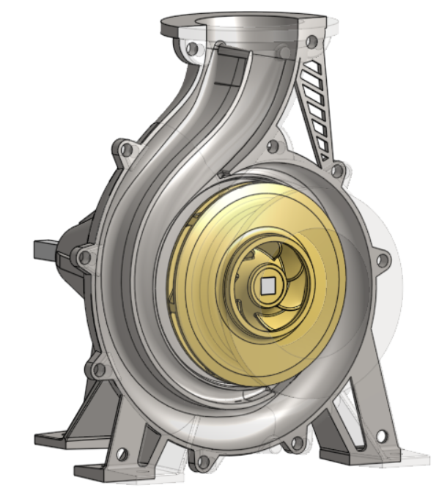
- Photo of the finished manufactured product
Couldn’t find it :(
Project: OnShape

Project 3: Solar heater
Objective
Develop a parabolic solar heater completely out of carton and aluminum foil that will make water inside a can boil.
Design Process
For our design the biggest problem was that it had to be made up entirely out of carton. We first started with a solid structure capable of being handled a lot and titling 360 degrees, so the sun always hits it directly, and all the heat is completely concentrated in the focus of the parabola.
Manufacturing
After designing it, it was cut using a laser cutter.
Images
- CAD render
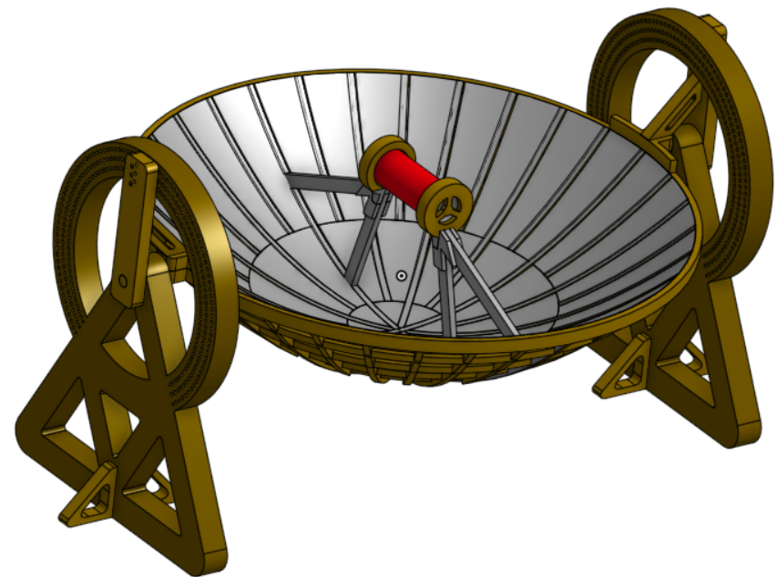
- Close-up views
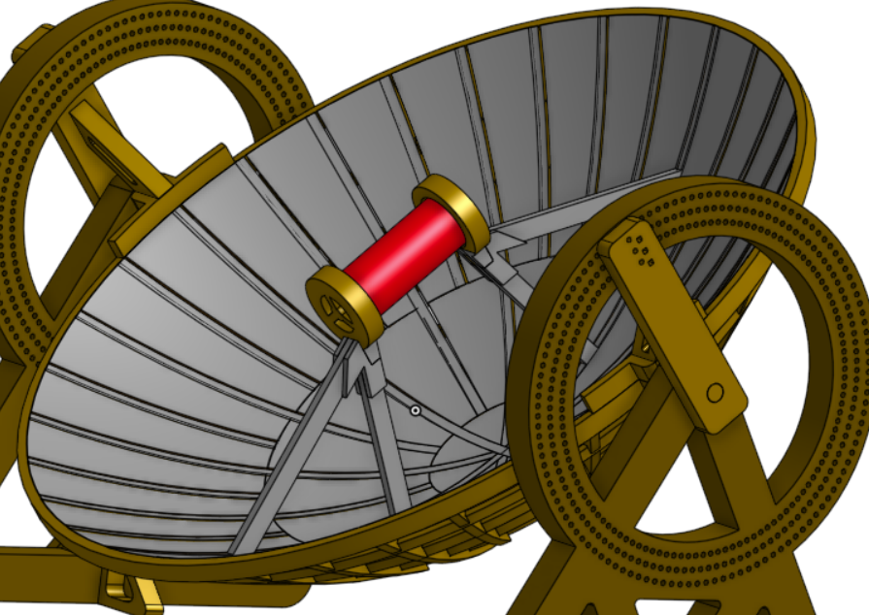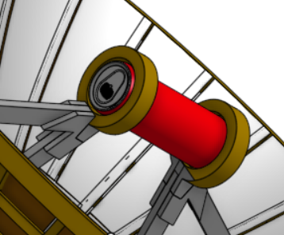
- Support view
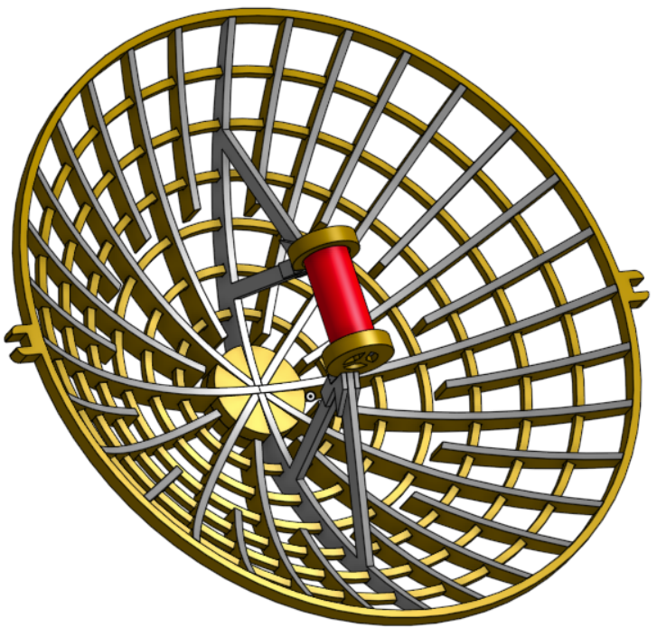
- Photo of the finished manufactured product
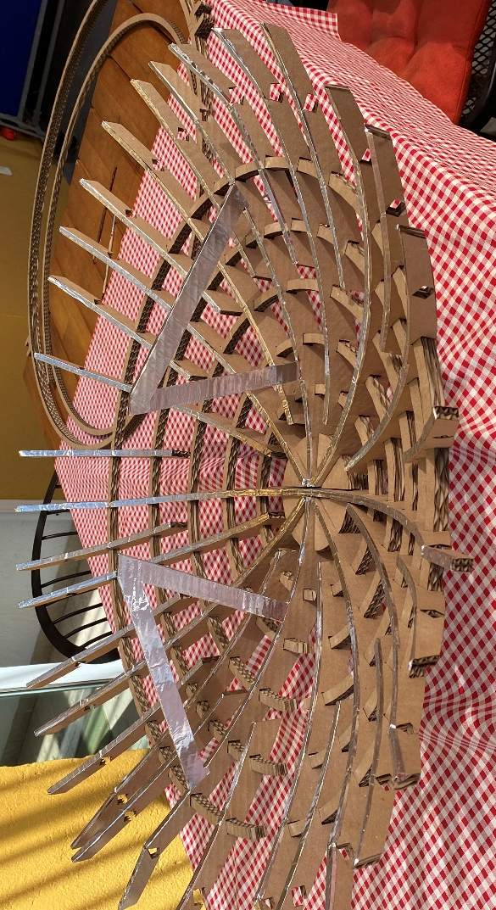
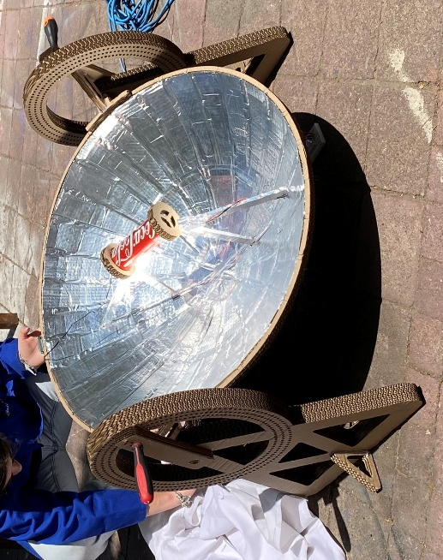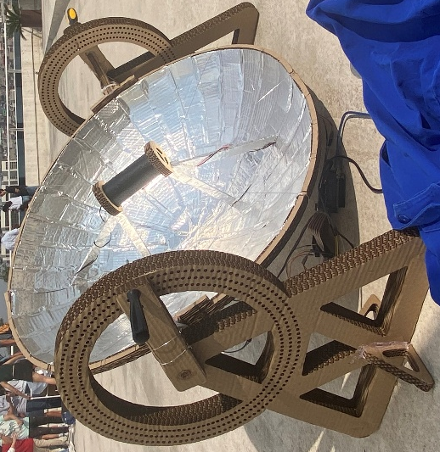
Project: OnShape
Project 4: Transformer
Objective
Study the influence of the distance between the primary and secondary windings in the final yielded current.
Design Process
Our design consisted of a tower with two interconnected infinite screws to ensure that the distance can be progressively increased.
Manufacturing
It was made from wood and existing parts. The wood parts were manufactured using Router CNC.
Images
- CAD render
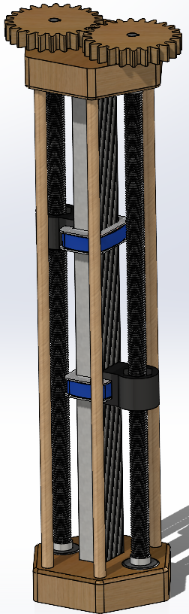
- Close-up view
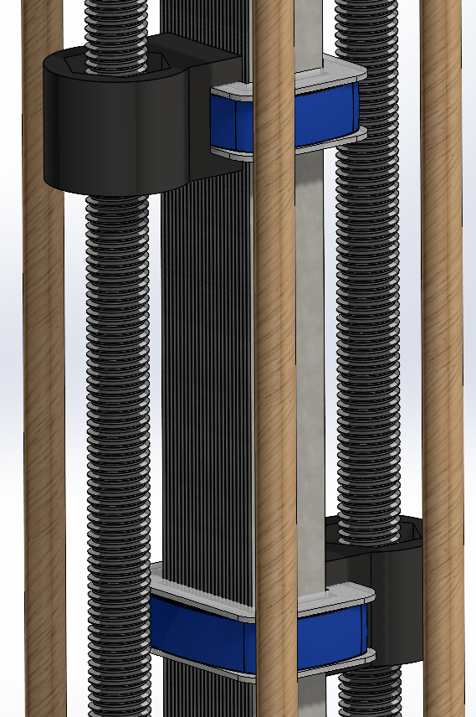
- Exploded view
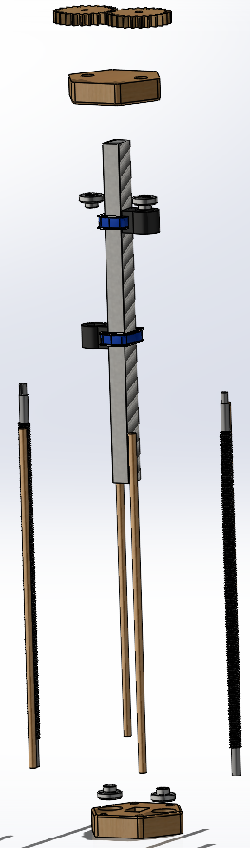
- Photo of the finished manufactured product
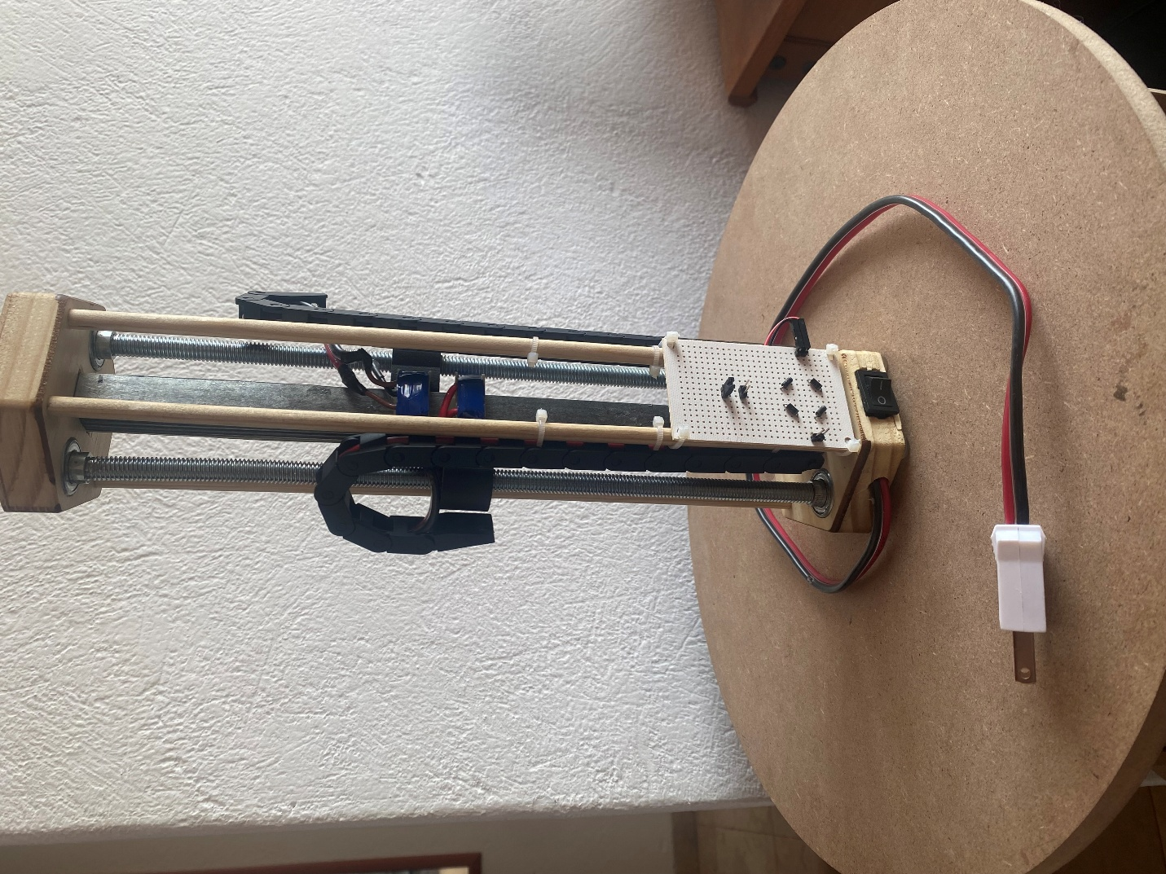
Project: Made in SolidWorks

